d

| No. of Pages | **3** |
| --- | --- |
| No. of Questions | **3** |

**Department of Computer Science and Engineering**

**MIDTERM EXAMINATION SPRING 2018**

**CSE421: Computer Network**

**Total Marks: 45 Time Allowed: 50 minutes**



* Answer ALL **THREE (3)** questions
* Figure in bracket [] next to each question indicates marks for that question



**Question 1**

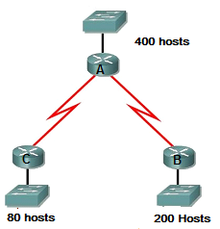

1. Suppose a company is given a block **220.32.192.0/22.** Show how you can create multiple subnets out of the original network address as per host requirements as shown in figure no. 1. Do not forget to show basic calculations. [8 marks]

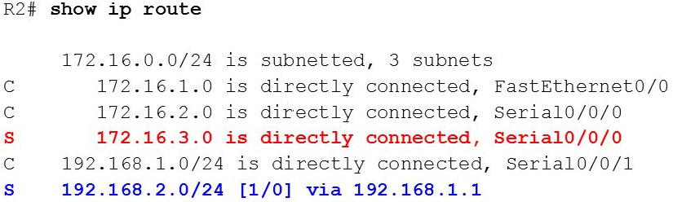



1. Refer to the routing table shown in figure no.2. Why is the cost of static routes zero? The two static routes configured are displayed differently, why? [1+3 marks]
2. An administrator issues the command on a router. [2+1 marks]

**R1(config)# ipv6 route ::/0 2001:db8:acad:6::1 10**

1. How can we make this command more efficient?
2. What is the number “10”?

**Question 2**

| **Node D Table** | | |  |  |
| --- | --- | --- | --- | --- |
|  | **C** | **D** | **E** | **F** |
| **D** | 8 | 0 | 2 | 6 |

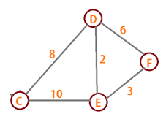

| **Node E Table** | | |  |  |
| --- | --- | --- | --- | --- |
|  | **C** | **D** | **E** | **F** |
| **E** | 10 | 2 | 0 | 3 |

| **Node F Table** | | |  |  |
| --- | --- | --- | --- | --- |
|  | **C** | **D** | **E** | **F** |
| **F** | ∞ | 6 | 3 | 0 |



1. The tables represent the routing table of Router D, E and F at a single point of time. Router F receives updates from D and E routers. All routers are running Distance Vector algorithm. How will Router F calculate the best paths to all destinations after receiving the updates from D and E only? (Use Dx(y) = min{c(x,y) + Dy(y), c(x,z) + Dz(y)} for explaining your answer) [6 marks]

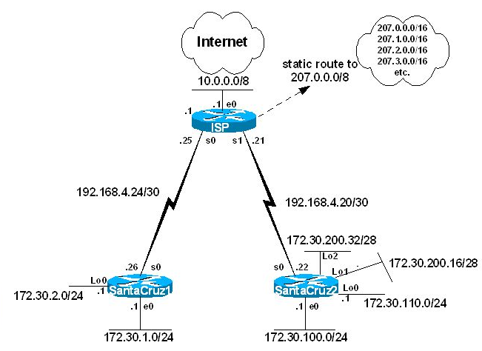



1. Refer to the above figure no. 4, all routers are running RIPv2. Router SantaCruz1 does not wish send the information regarding 172.30.2.0/24 network to its neighbor ISP. And also it does not want to send updates to its Ethernet interfaces. How can we implement both of the conditions? [3+2 marks]



1. Refer to the above figure no. 4, all routers are running RIPv2. There is a static route configured in the ISP router as shown above. Will the other two routers SantaCruz1 and SantaCruz2 have this route in the routing table or not? [4 marks]

**Question 3**

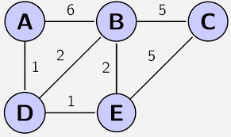

1. Link state routing protocol uses Dijkstra’s algorithm. Now using Dijkstra’s algorithm, compute the shortest path from Node **B** to all other remote networks shown in the figure no. 5. Use the table provided. [6 marks]
2. What are the tables that OSPF maintains and what do they contain? [4.5 marks]

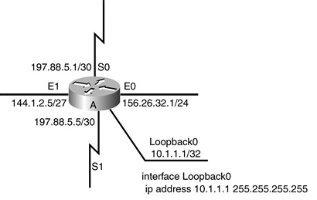

1. In the above figure no. 6, router A is running OSPF routing protocol. [1.5+3 marks]
   1. What will be its router ID?
   2. After a while the network administrator gives the following commands

**routerA(config)# router ospf 1**

**routerA(config)# router-id 2.2.2.2**

Now what will be router A’s router ID and why? 

**THE END**